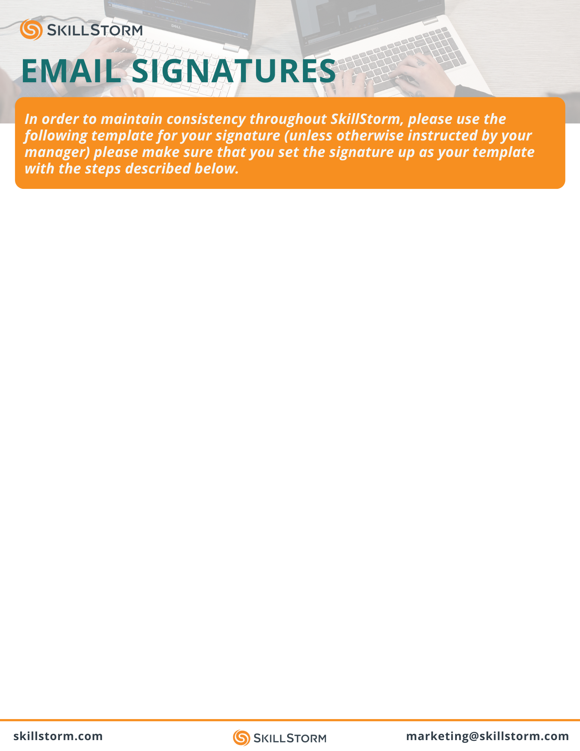

First & Last Name
Job Title

O 904.599.1235 | C 904.599.5548

 /First-Last
skillstorm.com



Step 1: From your Outlook homepage, click New Email located on Outlooks toolbar

Step 2: Once the New Email tab pops up, select Signature, located on the New Email’s toolbar

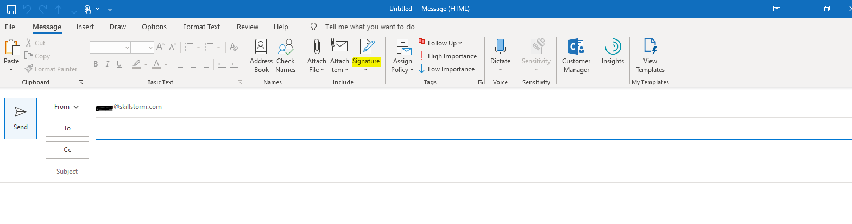


Step 3: From the Signature dropdown, click on Signatures...

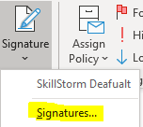

Step 4: Select the New option. This will prompt for you to type in the name for this signature template (recommended name: SkillStorm Signature).

Step 5: Copy and paste the signature template above with your custom information. Keep in mind to select this signature for Email Account, New Messages, and Replies/Forwards

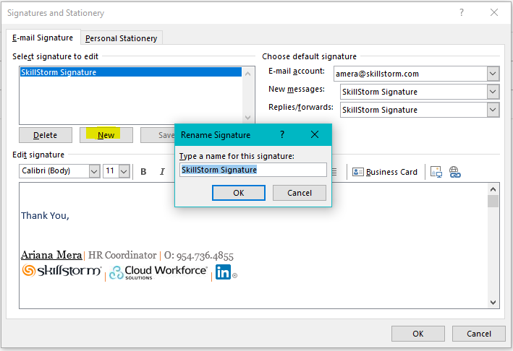

NOTE: Everything is linked in the signature already with the exception of your LinkedIn. You’ll notice the format listed for your LinkedIn section of your signature is /FirstName-LastName. If this is not your current LinkedIn URL, that’s ok!

Step 6: Highlight the LinkedIn section of your signature in the editor (including the LI Icon) and select the hyperlink button.

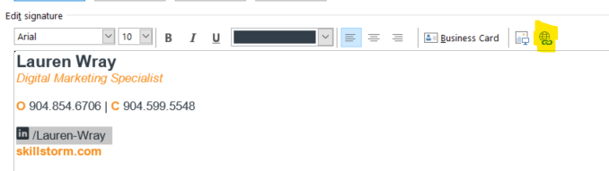

Step 7: Go to your LinkedIn Profile and copy your LI URL. Input that link into the Address Section of the Edit Hyperlink pop up. Once you’ve entered the link, click OK.

***The URL can be in whatever format on the backend, but make sure the display text in your signature still reads /First Name-Last Name.

If you’d like to update the link to follow this format, you can follow these instructions to update.

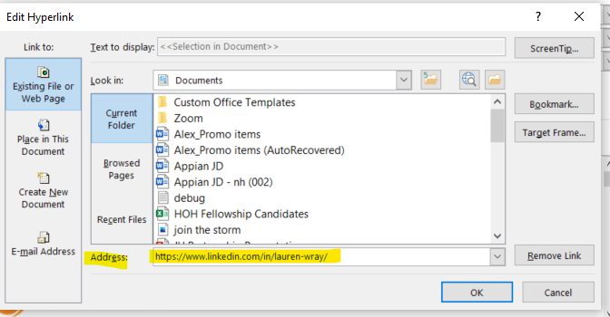

Step 8: Re-highlight your display text for your LinkedIn and make sure it is not underlined (like it is in the screenshot below). You may have to hit the U button twice.

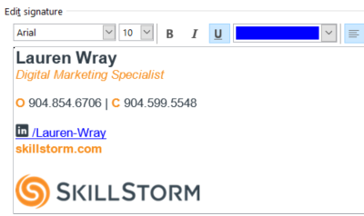

Step 9: While the LI section of your signature is highlighted, click the text color bar and hit More Colors.

Step 10: From there, click on Custom and enter #323e48 into the Hex section at the bottom.

Remember to include the #.

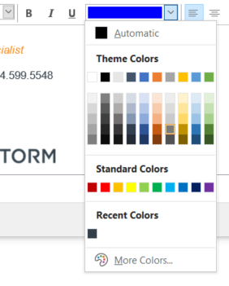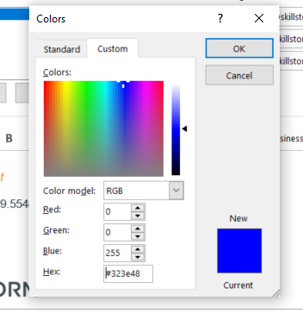

Click OK and you’re all set!

